**AN OPTIMAL SCHEME FOR CROP**

**RECOMMENDATION SYSTEM USING DEEP LEARNING CLASSIFICATION APPROACH**

First A. Author, *Designation, Organization*, Second B. Author, and Third C. Author, Jr., Designation, Organization

*Abstract*— India is one of the oldest and now farming nations. However, the patterns in agriculture have lately shifted significantly because of globalization. Different factors in India have influenced agriculture's health. The common problem among Indian farmers is that their soil requirements do not allow them to select the required crop. As a result, their productivity is severely reversed. This problem of the farmers has been addressed through precise crop recommendation system. In this paper, précised analysis can be done which helps the farmer to yield right crop at the right time. Initially, the database is collected and the input dataset is preprocessed. The feature selection is carried out followed by feature extraction techniques by using randomized Shearlet algorithm and recursive wrapper-based algorithm. The best features were then optimized using the Iterative convergent swarm optimization algorithm then the optimized output can be given as a input for the process of classification. The classification process is done using Discrete deep residual Alex Net Classification. The performance estimation is made to prove the effectiveness of proposed scheme.

*Index Terms*— Crop production, Discrete deep residual Alex Net Classification, randomized Shearlet algorithm, recursive wrapper-based algorithm, Precise crop recommendation system.

# INTRODUCTION

India is one of the largest farm products manufacturers, and its productivity remains very limited. Productivity has to be improved so that farmers can gain more with less energy from the same piece of land. Precision farming offers a means of achieving this. Precision agriculture, as it is called, requires the implementation at the right time of accurate and accurate overall commentaries such as pee, fertilizers, soil etc. to improve their productivity and increase their yields. Not all agricultural precision systems achieve best results. It is critical, however, in agriculture that the guidelines are correct and accurate as they can lead to heavy material and capital loss in cases of error. Because of technical advances there is a beneficial paradigm change in agriculture activities, but the slow growth of the population limits this benefit. For certain countries around the world and particularly in India, the intensity of population growth is very serious to address food requirements. As the population is rising exponentially, the market and supply situation is also under control. Generally speaking, demand for food rises annually with the country's rising population; accordingly, a large supply of crops with necessary yield rates and sustainability is required. These challenges can be addressed through sustainable agricultural activities. In order to change the environment, sustainable agriculture combines physical, social and ecological aspects. Sustainable precision agriculture encompasses economic, social and environmental facets. Sustainable agricultural practice's economic, social and environmental consequences. Economic considerations include costs of crop processing, productivity of crops, agricultural crop production rates. The higher productivity rate of agricultural production improves the agricultural economy, leading to employment and self-reliance in the agriculture industry. According to the Indian Planning Committee (PC), agriculture accounts for about 17.9% of the GDP, thereby performing a major role in the growth of independence. A social aspect focuses on the optimization of energy and would improve efficiency with less resource consumption, thus improving quality of life and raising living standards. Selection of crop trends plays an important role in a country's ongoing economic growth in order to become independent. There are all the elements required for the development of a given plant with respect to the ecosystem within the farming selection system. In a crop selection system, crop selection largely depends on the resource. Here this paper mainly focuses on the implementation of the decision optimization strategy for selection of the crops.

The rest of the paper can be organized as follows, section 1 depicts the basic introduction about the process of the decision making and optimization of the crop selection process. The related existing methodologies were depicted in section 2. The problem definition was depicted in section 3. The technique used for the crop selection is defined in Section 4, while the findings and explanation for the study is in Section 5. Section 6 ultimately summarizes the paper.

# Related Works

**[****1****]** Evaluated yield, water output (WEE), rainfall output (PUE) and net crop output based on established crop reactions to water usage by incorporation of grass/blade rotation.**[****2****]** Stresses the extent to which multiple environmental factors impact rainfall and also uses decisions on crop production such as disease detection and crop selection.[3] treats the comparative study of the GIS-based crop prediction interface machine learning algorithms (CSPM). **[****4****]** Presents a technical rice, coffee and cocoa support software that focuses on consumer feedback and external information, including location and climate that supports selection processes, control of, identification, avoidance of pests, fertilization selection, amongst others.**[****5****]** Presents the design of an electronic computer to examine farmers' paddy images and inform them. The primary purpose of creating a method for classifying rice diseases is to promote rice disease identification and classification **[****6****],** which include vector supports and artificial neural networks. The crop forecast takes account of parameters such as precipitation quantity, minimum and maximum temperature, soil type, humidity and the importance of soil pH. Data was obtained from Maharashtra's agriculture website. Data was broken into nine farming regions. **[****7****]** defining the main variables which affect the sugar cane yield and building mathematical models to predict sugar cane yield by using data mining techniques in accordance with their relative importance (DMs). To this end, three DM techniques were used to examine the bases of multiple sucrose mills in Sao Paulo, Brazil. Farm random methods, forest increase and vector assistance, and the resulting simulations were tested using an independent data collection. The data was then used for meteorological variables and forest plant management. The random forest algorithm of is used. **[****8****]** By analyzing the problems and concerns, such as weather, temperature, humidity, snow and precipitation, the condition we face and technologies cannot be correctly solved. There are many ways to promote economic growth in Indian agriculture. **[****9****]** The theory centered on fuzzy sets suggested. If the fluidity will occur, the volume of brightness for the measured grade should be assumed in pixels. If the uncertainty of images in the fuzzy package is effectively processed, particularly IFSs. When the segmentation activation can be determined by the satellite to decrease the uncertain capture images. The segmentation of crop deficits for the clustering technique then fuses an image, as it relies on the interval between the intuitionist furious set.**[****10****]** a new extract method has been proposed for the optimized sub-set function. Based on the method to be practiced for algorithms, the cultivation relies on the assist classification of vector machines. Total precision of about 89.6 percentage points will better determine technical efficiency. **[****11****]** using a chart rice crop based neural network algorithm and forecast the yield in the district of Terai. **[****12****]** establish necessary organizational laws and weighted aggregation operators needed. In it a new neutral addition and a scalar operating rule define the characteristics and the amount of probability in the member degrees of the group. Both facets of the introduced regulations are discussed. The introduction of machine learning methods to soil fertility studies in agriculture **[****13****]** was discussed. For a long time agriculture has been one of the areas of concern for science. The purpose of this study is to analyze, identify and develop soil data based on various factors. Technical advances like robotics have benefited from agricultural technology, data analysis. Data mining in big fields today is being used, and many off-shelf mining products and data mining applications in particular fields offer soft commodities, but data mining is a relatively recent area of research for agricultural soil datasets. The huge quantities of data now virtually collected from plants can be completely analysed and used [14] An updated neural MLP network will be developed with the new activation feature and revised random crop yield estimation weight and bias values, via various weather datasets. The MLP model has been tested with proven activation functionality and newly created activation functions, including weights and bias. In order to improve efficiencies and accuracy of neural networks, this study analyses the result of various activation potential and proposes various basic functions such as DharaSig, DharaSigm and SHBSig. Furthermore, three additional activation functions with small differences were developed with the DharaSig functions DharaSig 1, DHaraSig2 and DharaSig3. **[****15****]** The ET0 method for the estimation of data mining was explored in semi-arid China, using limited climate data. k-Nearest Nearest Neighbor Algorithm capacity was used in China. In addition, a KNN based ET0 prediction model was used to validate the PM-56 equation.

# PROPOSED WORK

Many predictive models use sub-sets of these influencing parameters for various crops. All of these prediction models for crop production are closely examined. The model of the prediction is usually classified into dual types: one is the standard statistical model (e.g., multi-linear regression models) which develops a single predictive function which comprises a whole sample space; second, machine learning is a new IT technology which applies to statistically complicated variables of input and output. Before traditional mathematical methods, the structure of the data model needs to be assumed, although machine learning techniques need not supposed this structure. This is useful for the estimation of crop production to model complex nonlinear behavior in the machine learning approach. As a learning tool widely used in forecasting technology, increasing technologies such as the RGF, GBDT, add boost, ID2, C4.5, and M5-Prime Regression treads are being used as teachers' lectures tool. Deep learning methodology across all these prediction technologies is still untouched in crop yield forecasting. Figure 1 demonstrates the methodology proposed to increase the crop yield based on decision-making using optimization. Here is a questionnaire focusing on unique farming attributes. For further processing of data and analysis, the data obtained are then used. In the modeling questionnaire for crop production, helps us to collect details from the plans for the cultivation method of many farmers.

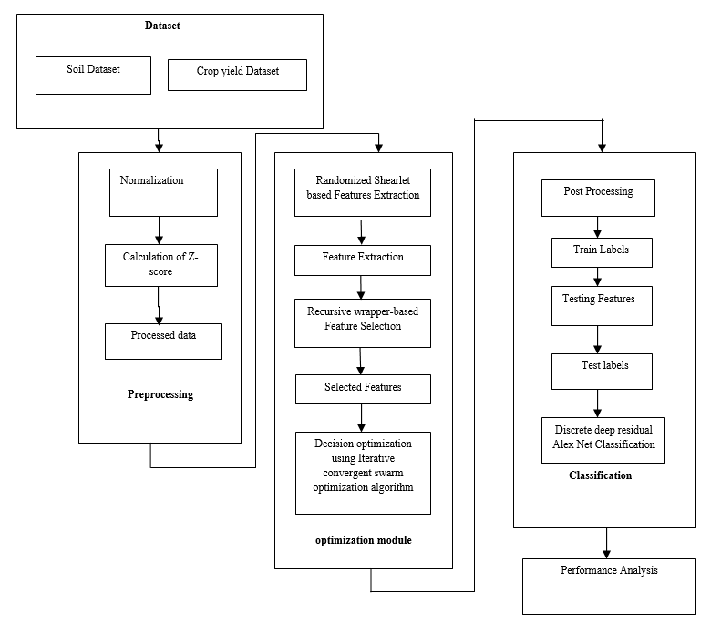

Figure 1 Schematic representation of the suggested methodology

**a.Preprocessing**

The initial stage of the data analysis is the pre-processing phase. The data will here be translated to a numerical format that is simple to grasp. An significant goal of this method is to remove invaluable terms. The standardisation would streamline the pre-processing level. The first phase in the method to assign the integer value is the mathematical encoding.

J=[(k- $µ$)/σ] (1)

Where *μ* is the mean of the data amount, and *σ* is the standard deviation of the data. While the data mean and standard deviation are not known, then the standard integer value will be assigned using the sample mean and standard deviation.

**b. Randomized Shearlet based features extraction**

During the feature extraction phase, the characteristics can be selected using the Shearlet method. This is a way to eliminate mathematical texture attributes of the second order. This technique has been used in a variety of applications, while three or more pixels communicate with textures in higher order. Usually, this is a math task that efficiently eliminates the artifacts. The precision of the data can also be explained. During the analysis cycle, the data features is separated. Shearlet may determine the frequency of the pixels in a specific region. The one data is being asked here and the Ø data attributes l and the neighboring m detachment of other data identified. Currently, m gets one value, and Ø will directly gain from it. The directional value obtained will delete the image attributes used during the process of feature extraction. The Shearlet process may set as follows:

K(i,d)=G(i,d,o, $Ø$)/ $\sum_{i=1}^{H}{\sum_{d=1}^{H}{G(}}$ I,d,o, $Ø$) (2)

Where G is the frequency vector, m, n, ois the frequency of the particular component will generally having the pixel values of l and m, K represents the features of an image, (i,d) was the component of the m and l, $Ø$ represents the normalized constant.

The various attributes can be obtained by applying the Shearlet approach. Then the features can be viewed by the recursive wrapper-based feature selection method.

**c. Recursive wrapper-based feature selection**

Feature selection methods that are used in different areas, including drug design, classification of diseases, image analysis, text mining, handwriting, speech recognition, social networking and many other fields, are important to modified extraction. In the field of crop selection data sets, nowadays, many methods for distinguishing features have been developed to provide much useful knowledge. The role collection methods are used for the selection of features from prediction databases. This is accompanied by the classification method**.** The method of choosing the relevant (appropriate) features of the model is therefore reduced training times and condensed models to facilitate understanding. The 8 functional attributes corresponding to the criteria are taken from the complete data set. There are two major feature filtering strategies: filters, wrappers and noisy data to pick the correct functionality. In case of data analysis, this technology can thereby increase the speed of performance and improve the prediction accuracy.

**d. Iterative convergent swarm optimization**

Particles in an ICSO scheme apply to the swarm of fly through the search field that solves the problem of optimization. The location of the particle is based on the best position it may visit (i.e. its own experience) and the position of the most relevant particle in its field (i.e. the experience of neighboring particles). Every particle's efficiency is calculated by using a fitness function that differs depending on the problems of optimization, i.e. the proximity of the particle to the global optimum. Particle in the swarm is labeled with the following properties taken into account:

$I_{i}$: Particle’s current position;

$v_{i}$: The current velocity of the particle;

$x_{i}$: represents personal best position of the particle.

For each step of a ICSO algorithm, the velocity vi was updated , specified for each dimension j = 1.. $N_{d}$

Where $N_{d}$ the dimension of the problem is Hence, $v_{ij}$ represents the $j^{th}$ element of the velocity vector of the $i^{th}$ particle.

The ICSO algorithm has been applied here in order to identify the best features to begin the further classification process.

**e. Discrete deep residual ALEX NET classification**

For classification, a discrete deep residual Alex NET classification may be recommended. One of the key issues with this sort of dataset is that several errors converge. The views then generally switch a bit so that after grouping, the optimization can be performed under Gone. There's an affinity in transition to a subclass. It is not called shear transformation because shear is insignificant. Thus the transformation becomes,

$A_{data}Transformation=\sum_{Pixel (x,y)}{[g_{match(1)}{i-\frac{Pixel}{2}}/{match}}$ + $g_{pixel(2)}{i-shape}/{match}$]/Pixel number (n) (3)

If a data is given, for each database we create several sub-data with the same number of details as the query. The records and databases have 1,2,... And so on the right. And so on the right. You will then find the correct crop and you can measure the distance from the Euclidean.

ED = $\frac{1}{n }$ $\sum_{p ∈ P}{\left( p-n\right)(p-n)^{T}}$ (4)

${ S}_{v}$ = θj=θj+Δ θj (5)

Finally, a ranking is generated for the suitable crops matching distance depends upon the data,

${obj}_{ED}$ =-20* q (-2 $\sqrt{\sum{S_{v}}}$*)/2-exp $(\sum{cos⁡(2π*S_{v})}$/ $d_{b}$)+20exp (6)

Where the ED signifies the Euclidean distance, q denotes the query data, and s is the output data score value.

$classify\left(A\right)={ED}_{j}^{l}$ (7)

The CNN classification was concluded as

$A_{d}$ = $N{(ED)}_{j}^{l} -N{\left({ E}_{j}^{l}D_{j}^{l} \right)}^{2}$ (8)

**Algorithm 1 (Discrete deep residual Alex NET deep learning Classification)**

***Input:*** *optimized data $O_{data}$*

***Output:*** *classified data $c_{d}$*

*Initialize the Network layers*

*Initialize train features*

*Initialize label data*

*Train label data =70%*

*Testt label data =30%*

*Label=unique(label)*

*For ii=1:lengh(Lab)*

*Class=find(label== Lab (ii))*

*Train cut=length(class)-train cut data*

*Train data=[train data; train features; class(1: Traincut)end-6:end]*

*Predict labeled data=classify(net,traindata)*

*End*

*End*

*For ii=8:size(traindata,5)*

*Traindata=[traindata; trainfeatures;class(1: Traincut)end-6:end]*

*End*

*For ii=8:size(trainfeatures,5)*

*Traindata=[ trainfeatures; trainfeatures;class(1: Traincut)end-6:end]*

*End*

# Performance Analysis

The experimental effects of the applied model are discussed in this section. There is the introduction of the modern decision-making paradigm and simulation. The tests are better and the accuracy is more accurate. Consequently, the ultimate effectiveness of the proposed solution is calculated in this section. The results and feasibility of the desired solution are estimated and applied to the estimation parameters.

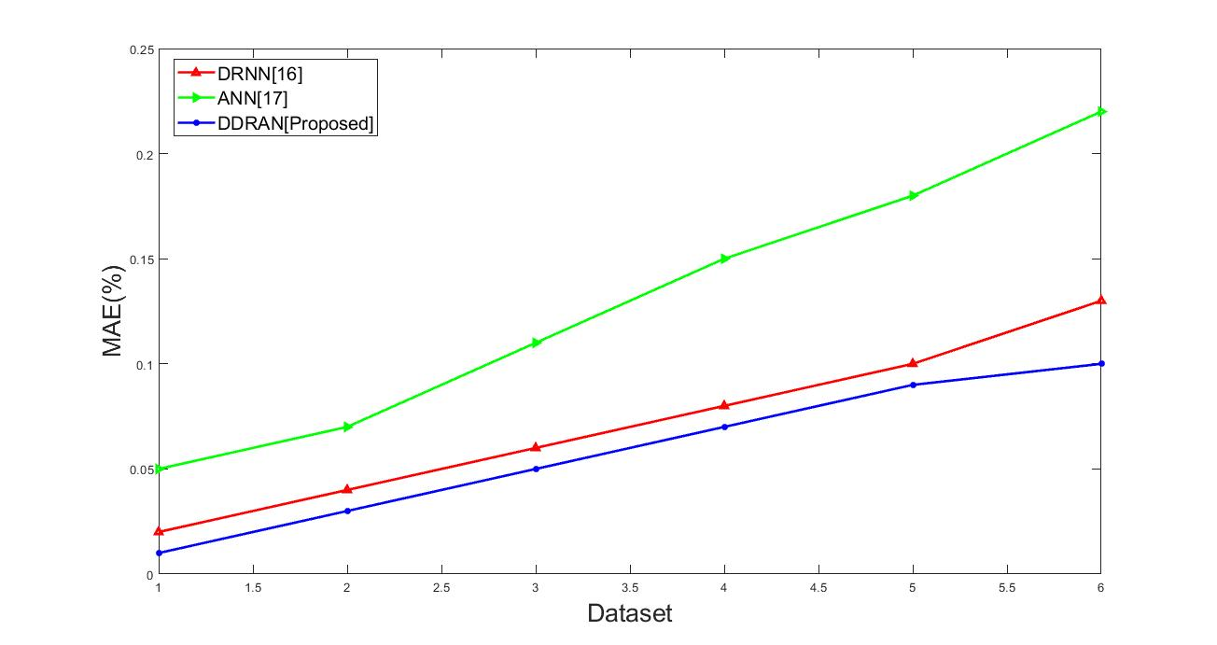

**Figure 2** Dataset Vs. MAE

Mean absolute error (MAE) in statistics is a measure of errors within pairing observations of the same phenomenon. It generally measures the accuracy of the continuous variables. It diagnosis the variation of the errors throughout the process. From figure 2 it will be revealed that the suggested classifier can express less errors than other existing mechanisms DRNN [16], ANN ANN [17].

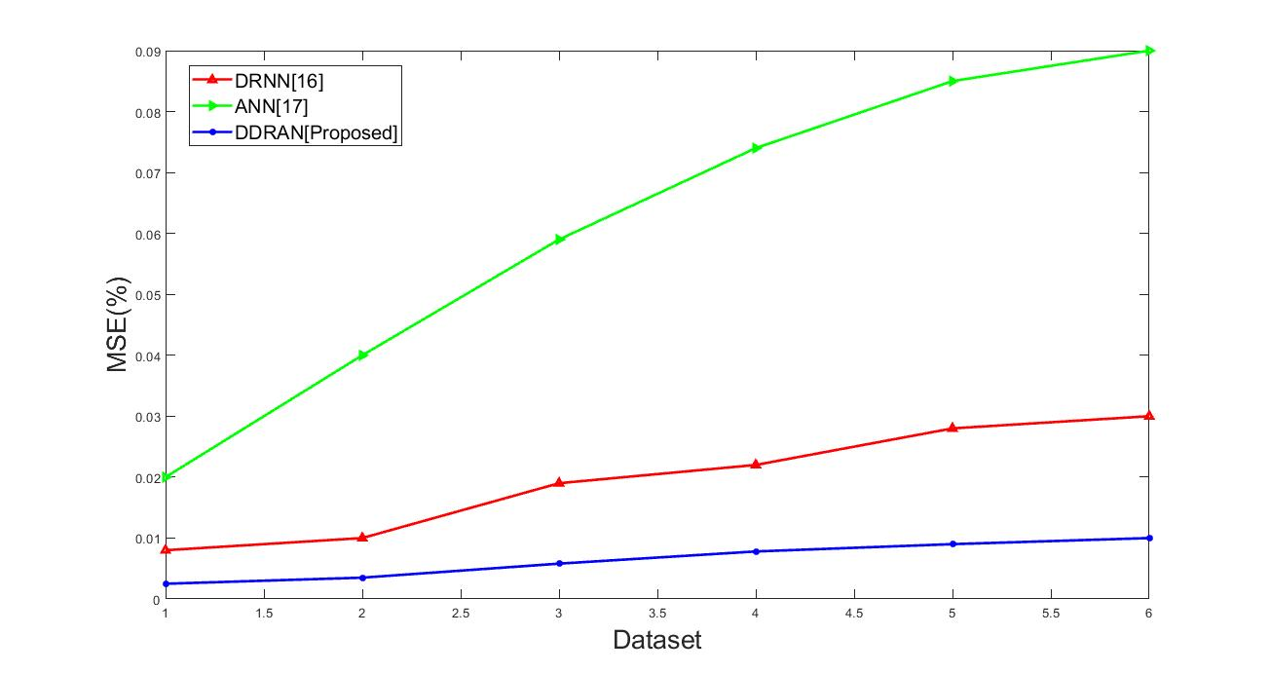

Figure 3 Dataset Vs. MSE

Statistics demonstrate that an estimator's mean squared error (MSE, mean squared error or MSD), i.e., the total squared discrepancy between expected value and real value, calculates the average of squares of error. As of from figure 3 the MSE value of the suggested mechanism shows better results than other existing mechanisms.

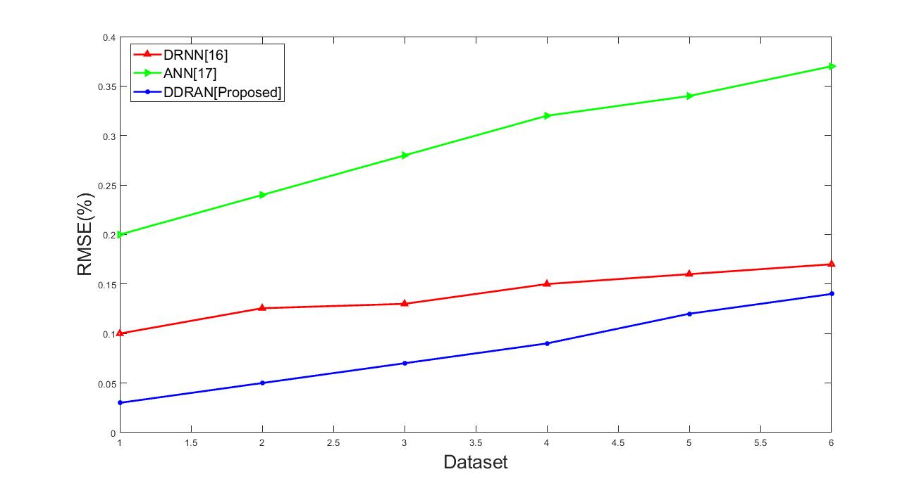

**Figure 4** Dataset Vs. RMSE

The standard deviation of the residual is root mean square error (RMSE) (prediction errors). Residuals are an indication of how far from the data points of the regression line; RMSE is a predictor of the distribution of these residuals. That is, it demonstrates how the data are focused in the right fit. From figure 4 it will be reveal that the lower values of RMSE indicate better fit when compared to other existing methodologies.

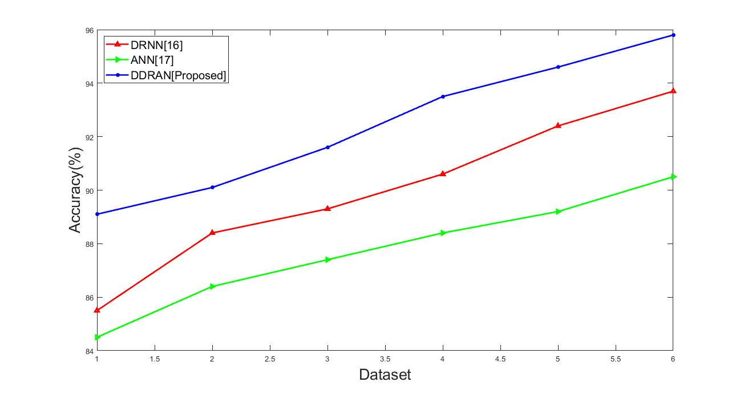

**Figure 5** Dataset Vs. Accuracy

It is a plot of organized errors, a predisposition measure; poor accuracy produces a difference between a outcome and a true value.   In certain instances, the data are checked with the same method, and how exactly the implemented model performs. The quality of the overall data is the percentage of actual outcomes (both positive and negative). The prediction accuracy of the suggested mechanism shows better results on crop prediction as depicted in figure 5.

# Conclusion

Deep learning models are commonly used to derive valuable predictive crop features. Although these approaches should overcome the problem of yield prediction. In this paper we use a ICSO+Discrete deep residual Alex NET deep learning algorithm that can be helps to classify the variety of crops based planting schedule. From this application, the proposed model focus at the theoretical model that can be attain for the performance for a better separation among the various types of crops in the planting-based schedule. Here for assessing the effective performance of the implemented method, it is compared with the three other existing methods which is proposed very recently. The performance of the proposed method shows effective results when compared to the other existing methods. This clearly shown that the proposed approach select crop which can yield higher profit in an effective manner.

References

[1] D. C. Nielsen, M. F. Vigil, and J. G. Benjamin, "Evaluating decision rules for dryland rotation crop selection," *Field Crops Research,* vol. 120, pp. 254-261, 2011.

[2] K. Lavanya, A. V. Jain, and H. V. Jain, "Optimization and Decision-Making in Relation to Rainfall for Crop Management Techniques," in *Information Systems Design and Intelligent Applications*, ed: Springer, 2019, pp. 255-266.

[3] P. Tamsekar, N. Deshmukh, P. Bhalchandra, G. Kulkarni, K. Hambarde, and S. Husen, "Comparative Analysis of Supervised Machine Learning Algorithms for GIS-Based Crop Selection Prediction Model," in *Computing and Network Sustainability*, ed: Springer, 2019, pp. 309-314.

[4] K. Lagos-Ortiz, J. Medina-Moreira, A. Alarcón-Salvatierra, M. F. Morán, J. del Cioppo-Morstadt, and R. Valencia-García, "Decision Support System for the Control and Monitoring of Crops," in *2nd International Conference on ICTs in Agronomy and Environment*, 2019, pp. 20-28.

[5] S. Das and S. Sengupta, "Feature Extraction and Disease Prediction from Paddy Crops Using Data Mining Techniques," in *Computational Intelligence in Pattern Recognition*, ed: Springer, 2020, pp. 155-163.

[6] T. K. Fegade and B. Pawar, "Crop Prediction Using Artificial Neural Network and Support Vector Machine," in *Data Management, Analytics and Innovation*, ed: Springer, 2020, pp. 311-324.

[7] R. G. Hammer, P. C. Sentelhas, and J. C. J. S. T. Mariano, "Sugarcane Yield Prediction Through Data Mining and Crop Simulation Models," vol. 22, pp. 216-225, 2020.

[8] M. Champaneri, D. Chachpara, C. Chandvidkar, and M. Rathod, "CROP YIELD PREDICTION USING MACHINE LEARNING."

[9] V. Ananthi, "Fused Segmentation Algorithm for the Detection of Nutrient Deficiency in Crops Using SAR Images," in *Artificial Intelligence Techniques for Satellite Image Analysis*, ed: Springer, 2020, pp. 137-159.

[10] J. Cui, X. Zhang, W. Wang, and L. Wang, "Integration of optical and SAR remote sensing images for crop-type mapping based on a novel object-oriented feature selection method," *International Journal of Agricultural and Biological Engineering,* vol. 13, pp. 178-190, 2020.

[11] T. Baidar, "Rice crop classification and yield estimation using multi-temporal sentinel-2 data: a case study of terai districts of Nepal," 2020.

[12] H. Garg, "Neutrality operations-based Pythagorean fuzzy aggregation operators and its applications to multiple attribute group decision-making process," *Journal of Ambient Intelligence and Humanized Computing,* pp. 1-21, 2019.

[13] R. Chaudhari, S. Chaudhari, A. Shaikh, R. Chiloba, and T. Khadtare, "Soil Fertility Prediction Using Data Mining Techniques."

[14] S. H. Bhojani, N. J. N. C. Bhatt, and Applications, "Wheat crop yield prediction using new activation functions in neural network," pp. 1-11, 2020.

[15] K. Feng and J. J. E. J. o. R. S. Tian, "Forecasting reference evapotranspiration using data mining and limited climatic data," pp. 1-9, 2020.

[16] D. Elavarasan and P. D. J. I. A. Vincent, "Crop Yield Prediction Using Deep Reinforcement Learning Model for Sustainable Agrarian Applications," vol. 8, pp. 86886-86901, 2020.

[17] M. Khodayar, J. Wang, and M. J. I. T. o. S. G. Manthouri, "Interval deep generative neural network for wind speed forecasting," vol. 10, pp. 3974-3989, 2018.